The ockham razor of creativity research in mathematics education

Bronislaw Czarnocha, William Baker & Olen Dias

Hostos Community College, CUNY, USA
bronisuavec2 @ gmail.com

The presentation proposes the theory of the Aha! Moment of Arthur Koestler (1964) as the Ockham Razor (OR) for the contemporary creativity research in mathematics education. The introduction presents a modern version of OR suggested by Einstein’s comment that "Everything should be kept as simple as possible, but no simpler". The modern version OR has two edges, one to “shave off” unnecessary concepts and assumptions, the other to integrate the concepts into irreducible wholes out of fragmented, oversimplified domain. We emphasize the scope of the integrative role of the second edge, which introduces high degree of coherence into the domain of creativity. We consider guardianship of domain coherence as one of the essential tasks of philosophy of mathematics education. The paper presents shortly the state of creativity research as the domain where many different definitions compete for the attention of teachers and researchers suggesting a need for “shaving off” unnecessary ones or integrate fragmented ones. In the next section elements of bisociation theory are stated together with their role as the components of OR in different aspects of creativity research.

Introduction
Ockham Razor (OR) is one of the oldest formal tools, which has been used to streamline the progress of knowledge and understanding. It is one of the principles underlying the philosophical discourse within Economy of Thought, a subject developed by E. Mach in his Science of Mechanics (1893), among others. His views were based on the principle “that science had the purpose of saving the mental effort.” Devised by William Ockham (c. 1287–1347), OR have guided Oresme, Galileo, Copernicus, Newton and its impact continuous till present days. In its John Punch’s, formulation of 1639, it tells us that "Entities must not be multiplied beyond necessity" or in modern terms "other things being equal, simpler explanations are generally better than more complex ones"; it’s a quest for simplicity of scientific expression, which however was wisely constrained by Einstein, who pointed out "Everything should be kept as simple as possible, but no simpler".
The comment of Einstein is significant for the discussion below. It suggests that the process of saving mental effort has two related routes: one by the minimal number of necessary assumptions, the rest being “shaved off” by Ockham Razor, the other by the quality of the structure within which given concept is formulated. That quality is often expressed by the precision and clarity of the relationships defining the schema of the concept in question, and it has an independent esthetical value. Consequently a modern OR has two different edges, one “to shave off” unnecessary concepts, and the other to integrate the concepts into irreducible wholes out of fragmented, oversimplified domain. Einstein’s comment leads then to a perfect completion of the Ockham razor pointing to the irreducible complexity present in reality and our understanding of it. Yet at the same time, Einstein,(1935) in his famous EPR paper titled Is Quantum Mechanical [QM] Description of Reality Complete attempted to introduce unnecessary hypothesis of “hidden variables” into QM. It was Niels Bohr’s (1935) structural argument that suggested that Einstein’s notion of reality is too limited to account for the observed effects of QM theory. We see here the degree to which the notion of simplicity is anchored in deep convictions of scientists.
The quest for simplicity in understanding increases in importance whenever we have many approaches to the subject, many different theories of the phenomena, which ultimately introduce confusion as to its ontological existence. In science, Ockham's razor is used as a heuristic technique (discovery tool) to guide scientists in the development of theoretical models, rather than as an arbiter between published models (Gauch, 1997). Here we aim at both of its roles. We introduce new theory of creativity into mathematics education while at the same time “shaving off” with its help several, in our opinion unnecessary, concepts within creativity research in mathematics education and, at the same time integrate others into necessary simple wholes.

State of Creativity Research - BRIEFly
There is an increase of interest recently in the classroom creativity of students of mathematics; Lamon (2003) emphasizes the need for creative critical thinking and Mann (2005) asks for the explicit introduction of creativity as the component of learning in general. However, the conceptualization of creative learning varies due to the diversity of the proposed definitions of creativity (Kattou et al., 2011). There is no single, authoritative perspective or definition of creativity (Mann, 2005; Sriraman, 2005; Leikin, 2011, Kattou et al., 2011) in the field of mathematics education. Whereas Mann (2005) found around 100 different definitions of creativity in the field, the main competitors are the Gestalt based theory of four stages of creative process proposed by Wallace (1927)/Hadamard (1945): preparation-incubation-illumination and verification, and (2) Thorance (1974), product oriented theory with fluency, flexibility and originality as indicators of creativity. We note the recent appearance of two excellent collections of papers, dealing with creativity in mathematics education, (Sriraman and Lee, 2011; Leikin et al, 2009), which bears witness to the increased importance of the subject. However, we also point out that both volumes‘ central focus is the relationship between creativity and giftedness. In the light of Srraman (2011) comment “There is almost little or no literature related to the synthetic abilities of ‘ordinary’ individuals, except for literature that examines polymathy”(p.120) there is a clear bias in the effort of creativity research. Prabhu and Czarnocha (2014) called for the democratization of research on creativity with its Arthur Koestler‘s (1964) definition as bisociation formulated in the The Art of Creation.

Koestler theory of creativity as Ockham Razor
Bisociation is “a spontaneous leap of insight which connects previously unconnected matrices of experience” (p. 45) - known also as an Aha!moment or Eureka experience. A bisociative framework is the framework composed of “two unconnected matrices of experience” where one may find a “hidden analogy” – the content of insight. The definition asserts that the presence of the bisociative framework is the necessary condition for Aha!moment to occur and it directs our attention towards the theory of schema formation. Before we proceed to explore the insight brought by the Koestler’s theory of Aha!Moment into schema formation, one should add that the theory of bisociation is the generalization of three separate investigations, into the nature of humor, nature of discovery and the nature of art, wherein in each he was able to find the same mechanism of bisociation as the root of the creative Aha!Moment experience. The Koestler triptych shows the process of horizontal merging of humor with discovery, and discovery with art, which have fundamentally different language of expression both on cognitive and affective planes. He points out how emotional, expressive content of panels changes while moving from left to right, while structure of bisociation mechanism stays the same throughout different domains.
Consequently bisociation solves the standard division of creativity into domain specific and domain general by positing presence of both components underlying creativity’s structure whenever it appears: the general principle of bisociation and its particular formulation and expression depending

Humor Discovery Art

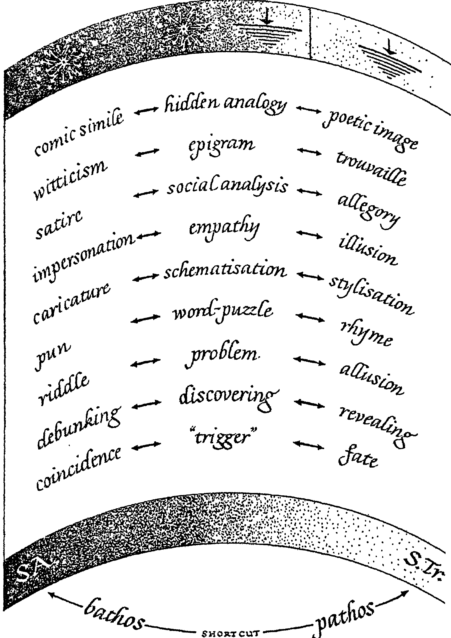

Fig. 1 Koestler Triptych: Humor, Discovery and Art.

on the domain. This is the first use of the second edge of the Ockham Razor. The presence of bisociation suggests that the division into domain specific or domain general is inessential because always both take place together. Equally deep integrative processes explicated from Koestler definition and described below allow to see the human creativity in a more coherent fashion.Guarding the coherence of the intellectual domain is in our opinion one of the fundamental tasks of philosophy of mathematics education.

The definition of bisociation as the leap of insight which connects unconnected matrices of experience or separate frames of reference suggests the process of schema formation to be the cognitive framework of Aha!Moment. Thus Bill Baker (2016) had demonstrated that bisociation constructively complements Piagetian theory of schema formation (Piaget and Garcia,1987) as the foundation for processes of reflective abstraction such as constructive generalization (von Glasersfeld, 1989) and interiorization (Dubinsky, 1991). The second edge of OR integrates creates here mutually reinforcing network of two theories: bisociation and Piaget theory of conceptual development. The definition focuses on the cognitive aspect of the Aha!moment; Koestler provides a series of supporting it examples such as Gutemberg discovery of printing press out of the bisociation framework between the wine press and a seal, or Poincare’s note describing formulation of hidden analogy between Fuchsian functions and hypergeometric series. We see close connection created between bisociative creativity and synthesis reflecting recent change within the theory of Bloom taxonomy where the last stage of synthesis has been substituted by creativity (Krathwool, 2002).

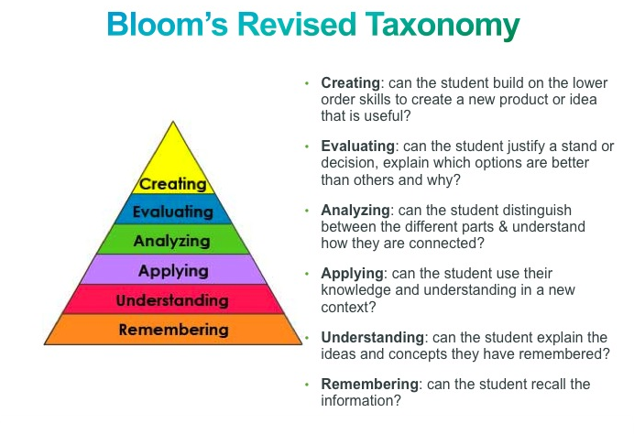
Fig. 2 Revised Bloom’s Taxonomy.

The emphasis on the schema construction together with the empirically observed positive impact upon thinker’s affect (Liljedahl,2013) allows to formulate the principle of cognitive/affective duality of Aha!Moment (Czarnocha, 2014). We are questioning here the approach of Liljedahl (2013) who asserts “That…, what sets the phenomenon of illumination apart from other mathematical experiences is the affective component of the experience, and ONLY the affective component” by suggesting cognitive/affective duality as the central quality of the Aha!moment. Koestler’s assertion: “The creative act…is an act of liberation-the defeat of habit by originality” allows one to exploit cognitive/affective duality in the combat with negative habits hampering students’ success in mathematics, especially of those among “underserved” population (Vrunda Prabhu, 2015). The second edge of OR brings forth the cognitive component as its characteristic and creates the dynamic cognitive connection with affect.

Koestler places his definition of creativity on the interphase between incubation and illumination of the gestalt model of creativity with its four stages while emphasizing originality as the characteristic feature of creativity. By “shaving off” preparation and verification of the Gestalt definition, as well as “fluency and flexibility” of the Thorance, Leikin, Silver definition using the main edge of OR, he constructs bisociation as the dialectical synthesis of both with the help of the second edge of OR. He points that both fluency and a component of flexibility are habit-based and as such can diminish originality, and therefore, creativity. In fact reports of Leikin et al (2013) inform about diminished originality during the teaching experiment based on Torrance definition.

The final at present connection created by the meaning of bisociation is physiological. As bisociation is obtained by connecting simultaneously “ previously unconnected matrices of experience”, it necessitates simultaneity of attention to two different “matrices of experience”. This is significant because in history of modern physics the notion of simultaneity appeared twice at the very foundation of two physical theories, Theory of Relativity and Quantum Mechanics. One can surmise that its appearance in the theory of creativity will be equally, if not more, fundamental, especially considering that, quite possibly, creativity is incompatible with the habit, and therefore, the measurement of creativity maybe similarly constrained as are measurements of incompatible observables of QM.

The second area of creative coherence is identified by bisociation in the area of classroom teaching and learning. The central point of bisociation as the new definition of creativity in mathematics education emphasized by Prabhu and Czarnocha (2014) has been the possibility to democratize research on creativity. Since Aha!Moment is a popular experience experienced essentially by everyone, the investigation and related facilitation of that experience mean the focus on the “creativity of all”, that is not primarily gifted population as is the prevailing custom, but of course including the gifted as well.

Aha!moments are common experiences within members of general population, and, accordingly to Koestler, are often encountered in conditions of “untutored learning”. What’s more, we have importantant Hadamard (1945) statement: Between the work of the student who tries to solve a problem in geometry or algebra and a work of invention, one can say that there is only the difference of degree, the difference of a level, both works being of similar nature (1945, p.104). These three different observations suggest that investigations into Koestler’s definition will democratize research and redirect it into everyone’s creativity (including gifted learners), it will explore the role of Discovery method of teaching as the best classroom approximation to conditions of “untutored learning”, and together with its cognitive/affective duality it will provides the foundation to bridge the Achievement Gap. Again we witness the integrative power of bisociative creativity in putting several different, separated components into construction of the whole of creative learning environment (Prabhu, 2016).

Similar coherence appears on the teaching spectrum of the classroom ethos. First, the methodology of teaching-research as connecting two, in general separate disciplines of teaching and research, turns out to be a bisociative framework, albeit very creative one confirming the role of bisociativity.
Awareness of the bisociative coherence of TR/NYCity model has been facilitated by the work of Margaret Eisenhart (1991 who identified three frameworks of inquiry present in research of Mathematics Education: theoretical, practical, and conceptual (Lester, 2010). Following Eisenhart, Lester (2010) posits three types of frameworks used in Math Education, first, the theoretical framework based upon theory i.e. the constructivist, radical constructivist and social constructivist theories discussed second, a practical framework, “… which guides research by using ‘what works’ … this kind of research is not guided by formal theory but by the accumulated practice knowledge of practitioners and administrators, the findings of previous research, and often the viewpoints offered by public opinion” (p. 72). The third is a conceptual framework that can pull from various theories as well as educational practice. We argue that amongst the three frameworks for research present in philosophy of education research only the conceptual framework allows for the possibility of bisociative synthesis between teaching and research through Stenhouse TR acts.
“a conceptual framework [that] is an argument that the concepts chosen for investigation, and any anticipated relationships among them, will be appropriate and useful given the research problem under investigation. Like theoretical frameworks, conceptual frameworks are based on previous research, but conceptual frameworks are built from an array of current and possibly far-ranging sources. The framework used may be based on different theories and various aspects of practitioner knowledge” (Lester, 2010).
Of special importance in working with conceptual frameworks is the notion of justification. A conceptual framework is an argument including different points of view and culminating in a series of reasons for adopting some points and not others. The adopted ideas or concepts then serve as guides: to collecting data, and/ or to ways in which the data from a particular study will be analysed and explained (Eisenhart, 1991)

The development of the TR methodology from the bisociative point of view encompassed Stenhouse acts that is acts which are simultaneously a teaching act and a researcher act, or a bisociative act. This Stenhouse quality becomes the criterion with the help of which we decide whether a particular classroom act is intrinsically TR act. We identified Discovery method, the method of teaching-research interviews, facilitation of Aha!Moment as such distinctive bisociative TR methods. Consequently another whole was created by the second OR edge composing bisociative teaching-research as the classroom investigation with the Discovery method of teaching particularly suitable for the facilitation of Aha!Moment.

Fig. 3 Ockham Razor as the Scarabeus of bisociation

References
William Baker (2015) Koestler Theory as a foundation for Problem Solving in B.Czarnocha, William Baker, Olen Dias, Vrunda Prabhu (2015) The Creative Enterprise of Mathematics Teaching-Research. To be published by Sense Publishers.
Bohr, N. Can Quantum Reality be Considered Complete? Phys. Review, 48.696.
Czarnocha (2015) Teaching-Research NYCity Model in Koestler Theory as a foundation for Problem Solving in B.Czarnocha, William Baker, Olen Dias, Vrunda Prabhu (2016) The Creative Enterprise of Mathematics Teaching-Research. To be published by Sense Publishers.
Czarnocha, (2014). On the Culture of Creativity in Mathematics Education. Teaching Innovations,vol.27 N 3
Czarnocha (2008) Ethics of Teacher-Researchers in B.Czarnocha (ed) Handbook of Mathematics Teaching-Research, University of Rzeszow.
Dubinsky, E. (1991). Reflective abstraction in advanced mathematical thinking. In D. Tall (Ed.), Advanced Mathematical Thinking (pp. 95-126). Dordrecht: Kluwer Academic Publishers.
Einstein, A., B. Podolsky, N.Rosen (1935) Can Quantum Reality be Considered Complete? Phys Review., 47,777.
Hugh G. Gauch, Scientific Method in Practice, Cambridge University Press, 2003
Hadamard, J. (1996), The Mathematician's Mind: The Psychology of Invention in the Mathematical Field, 1996. ISBN 0-691-02931-8
Maria Kattou, Katerina Kontoyianni, Demetra Pitta Pantazi, Constantinous Christou (2011) Does Mathematical Creativity Differentiate Mathematical Ability? Proceedings CERME 7, p.1056, Rzeszow, Poland.
Arthur Koestler‘s (1964) The Act of Creation. Hutchinson & Co (publishers), LTD. London,W1
Krathwohl, D.R. (2002) A revision of Bloom Taxonomy. Theory into Practice 41(4)
Lamon, S. (2003). Beyond constructivism: An improved fitness metaphor for the acquisition of mathematical knowledge. In R. Lesh & H. M. Doerr (Eds.), Beyond constructivism: Models and modeling perspectives on mathematics problem solving, learning and teaching (pp.435-448). Mahwah, NJ: Lawrence Erlbaum and Associates.
Roza Leikin, Anat Levav-Waynberg, Raisa Guberman (2011) Employing multiple-solution-tasks for the development of mathematical creativity: two comparative studies. In M. Pytlak, T. Rowland, E. Swoboda (eds) Proceedings of the seventh Congress for European Research in Mathematics Education,Rzeszow, Poland.
Liljedahl, P., (2013) Illumination: an affective experience, The International Journal of Mathematics Education, 45: 253-26==
Mann, (2005) Mathematical Creativity and School Mathematics: Indicators of Mathematical Creativity in Middle School Students (Doctoral dissertation).
Piaget, Jean and Garcia, Roland (1987) Psychogenesis and the History of Science. Columbia Press
Vrunda Prabhu, Bronislaw Czarnocha (2014) Democratizing Mathematical Creativity Through Koestler’s Bisociation Theory in Oesterle, S., Liljedahl, P., Nicol, C., & Allan, D. (Eds.). (2014). Proceedings of the Joint Meeting of PME 38 and PME-NA 36 (Vol. 3). Vancouver, Canada: PME.
Torrance, E. P. (1974). Torrance tests of creative thinking. Bensenville, IL: Scholastic Testing Service.
Sriraman, Bharath (2005) Are Giftedness and Creativity Synonyms in Mathematics? The Journal of Secondary Gifted Education. V17,N 1.
Bharat Sriraman, Narges Yaftian, Keeong Hwa Lee (2011) Mathematical Creativity and Mathematics Education: A Derivative of Existing Research in Sriraman and Lee (eds) The Elements of Creativity and Giftedness in Mathematics, Sense Publishers.
Wallas, G. (1926) The Art of Thought. New York: Harcourt Brace
Von Glasersfeld, E. (1989a). Cognition, construction of knowledge, and teaching. In Synthese 80(1), pp. 121-140.

